Jenna de Beer

ST10092652

NEPR7312

Portfolio of Evidence: Part One

*Virtual Machine Configurations*

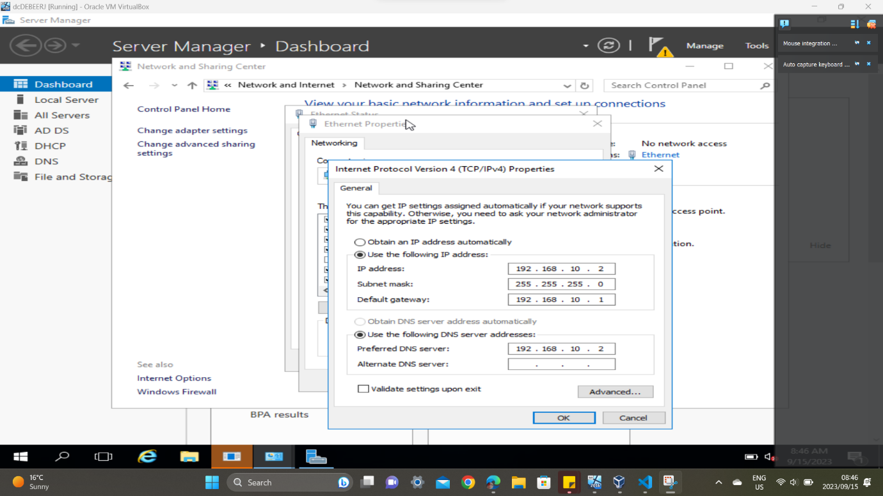

Figure 1 - Server computer: Properties

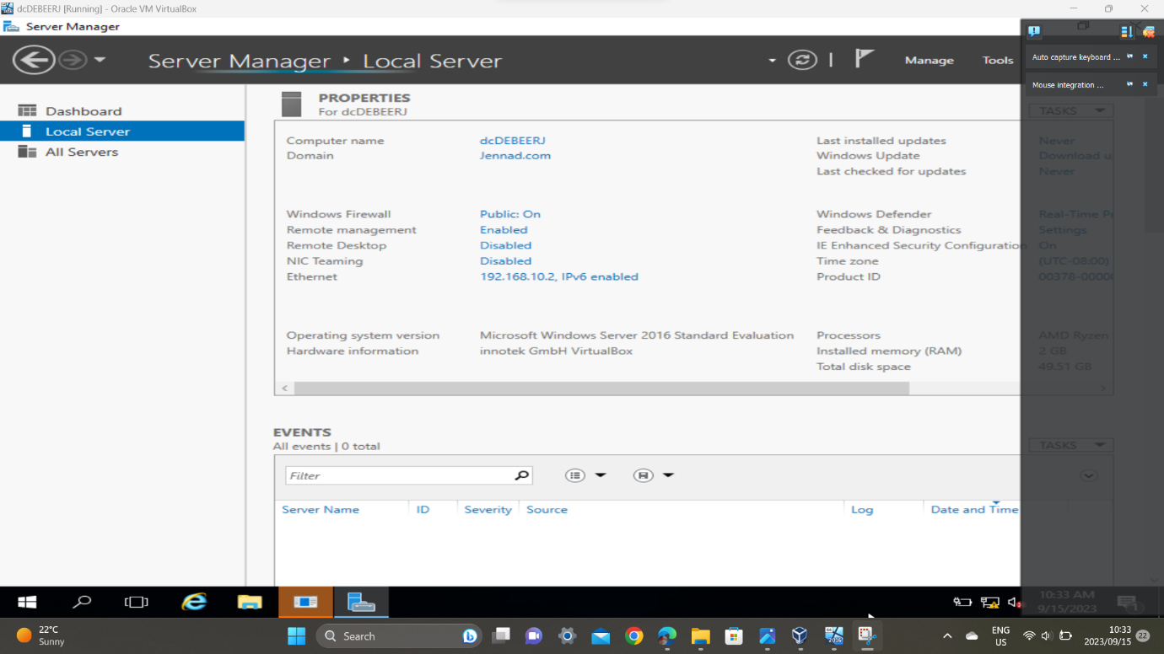

Figure 2 - Server computer: Name and domain

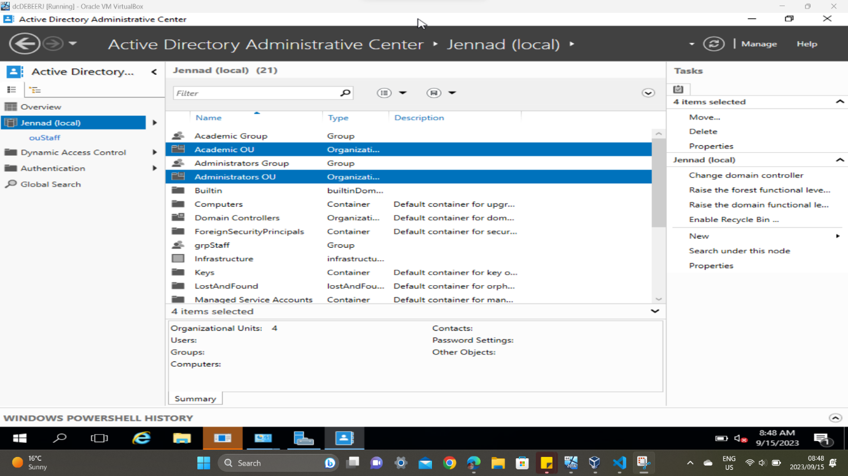

Figure 3 - Server computer: OU groups

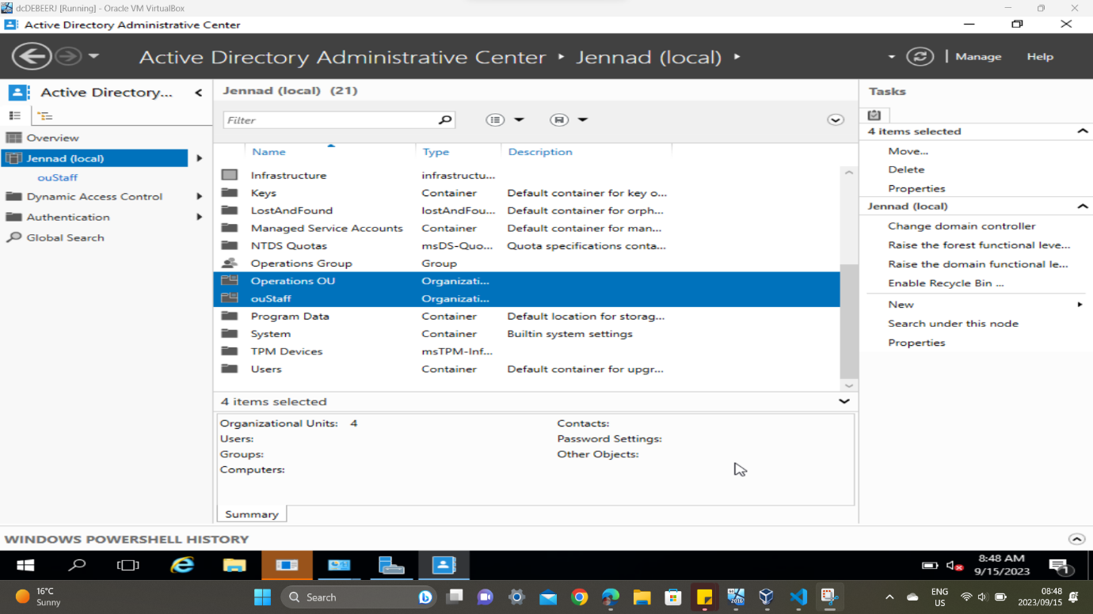

Figure 4 - Server computer: OU groups

Figure 5 - Server computer: ouStaff

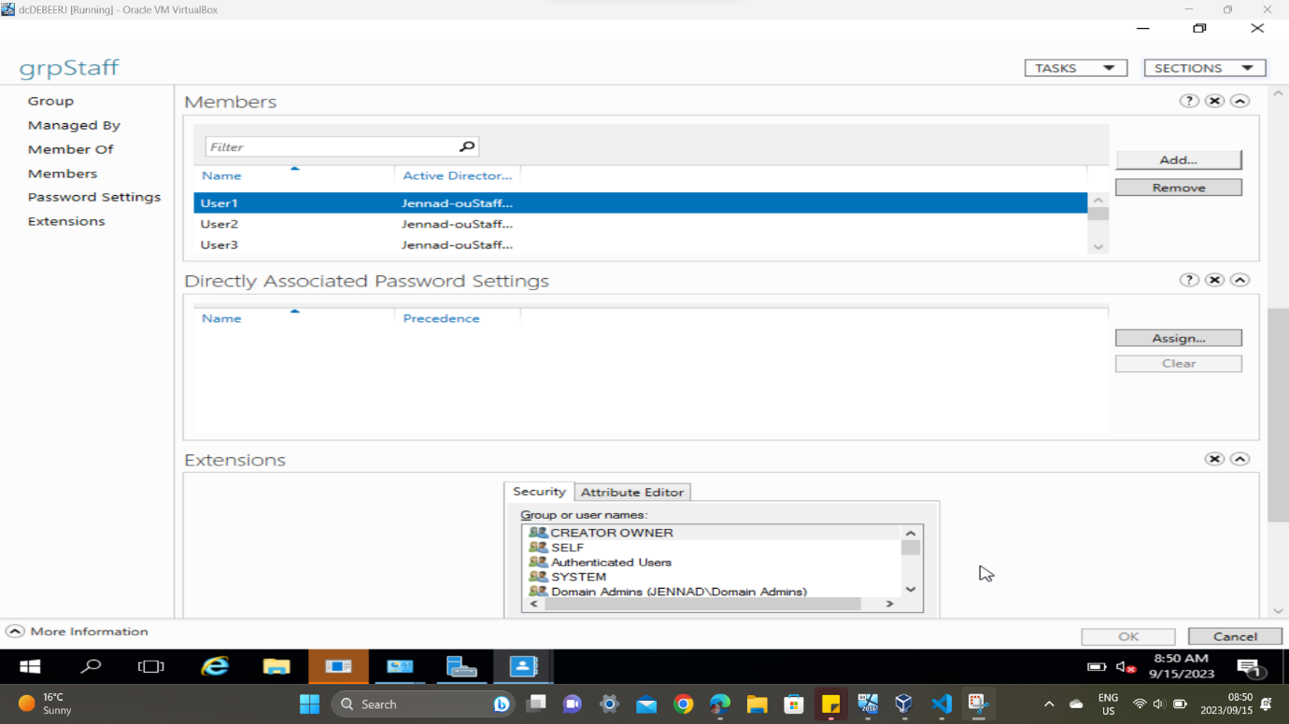

Figure 6 - Server computer: grpStaff users

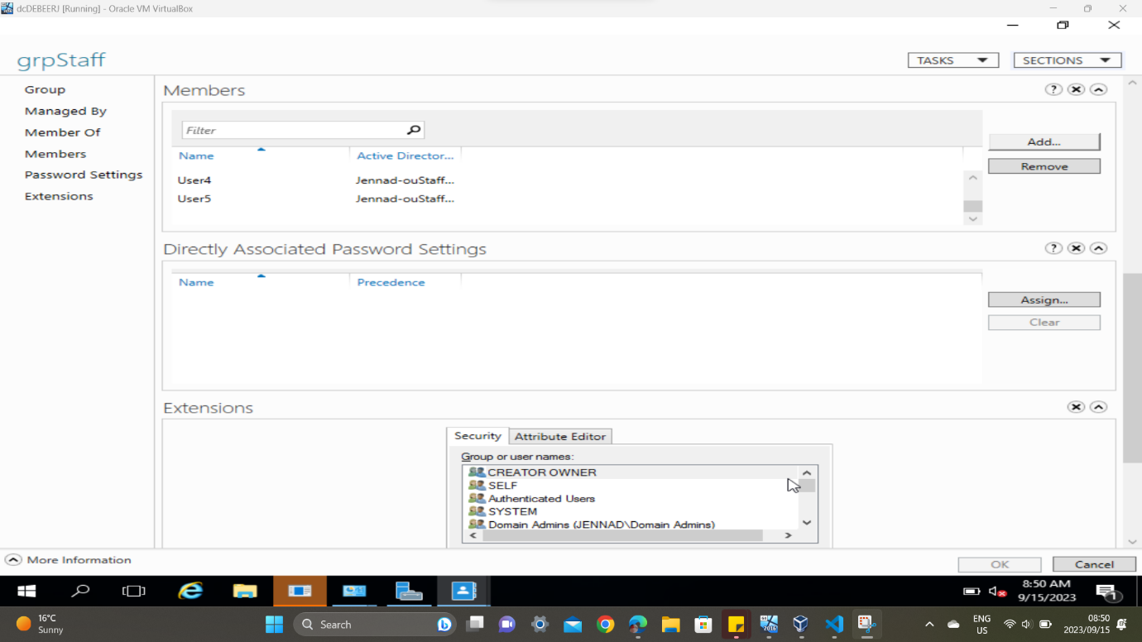

Figure 7 - Server computer: grpStaff users

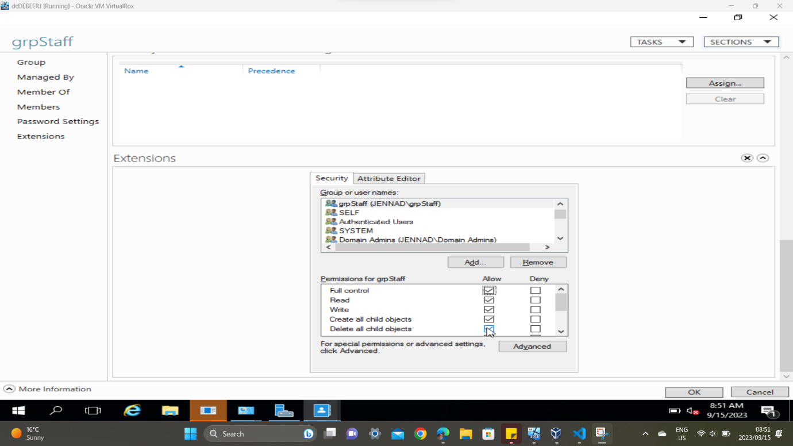

Figure 8 - Server computer: grpStaff permissions

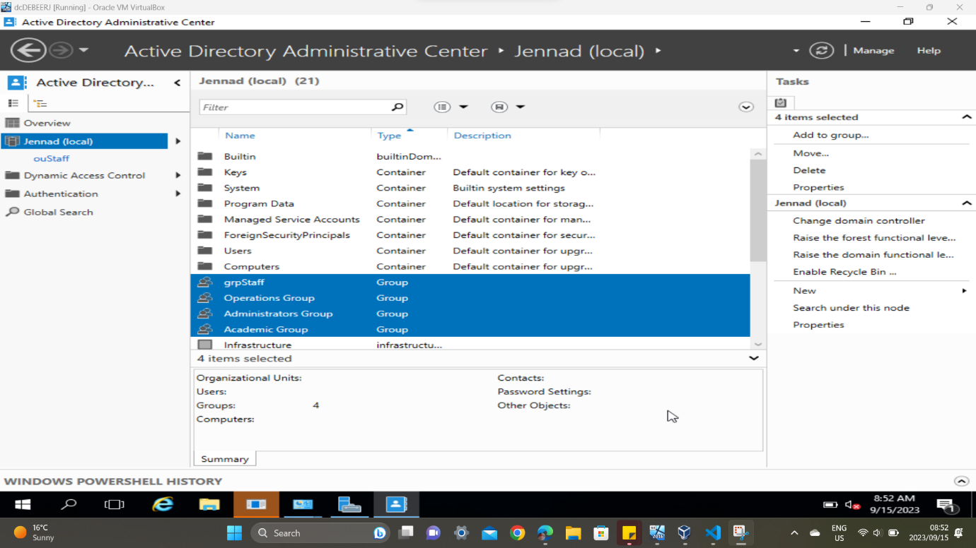

Figure 9 - Server computer: Groups

Figure 10 - Server computer: Group permissions

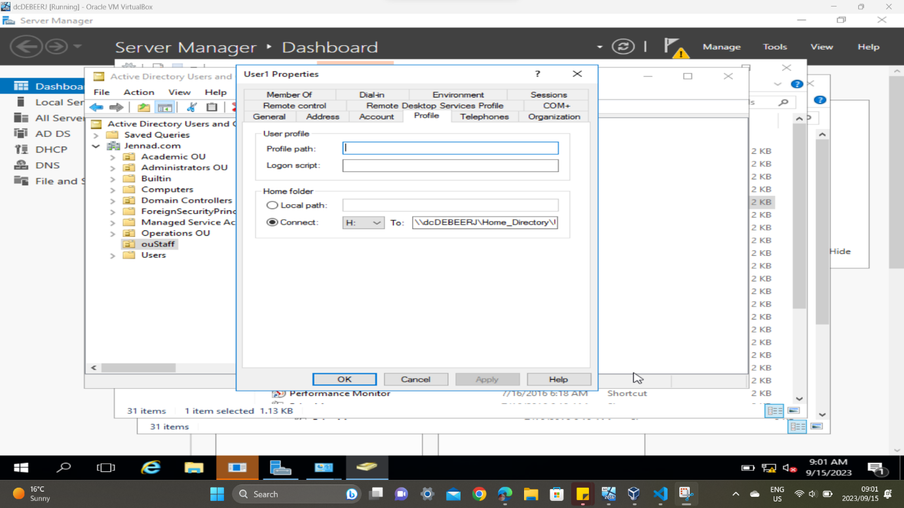

Figure 11 - Server Computer: ouStaff user properties

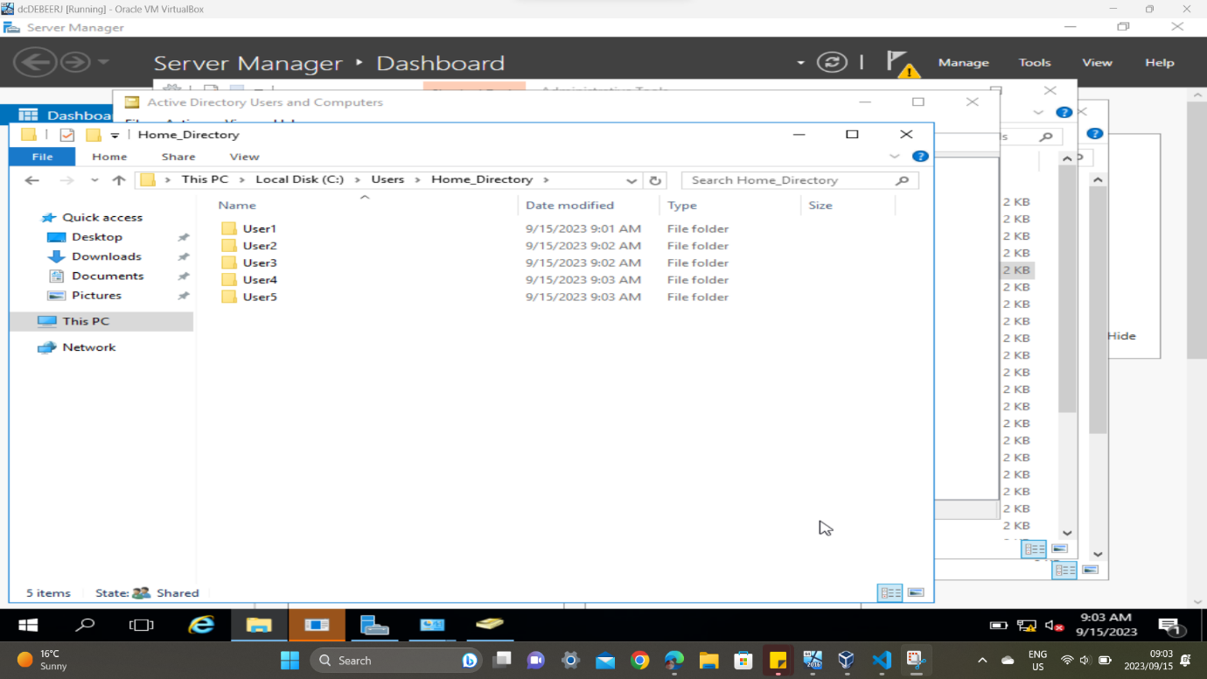

Figure 12 - Server Computer: ouStaff users

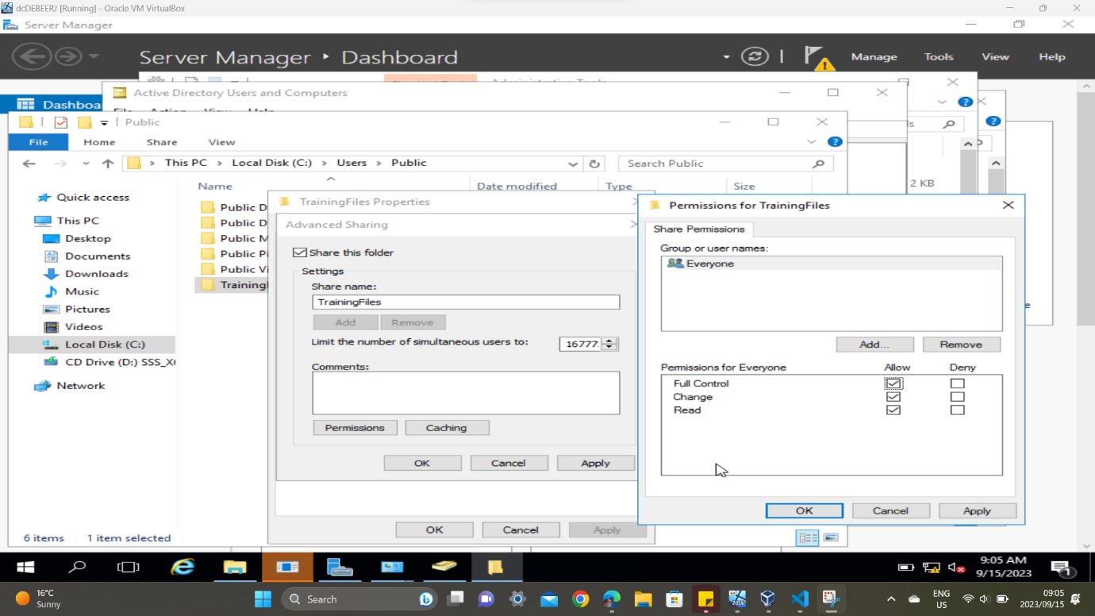

Figure 13 - Server computer: TrainingFiles permissions

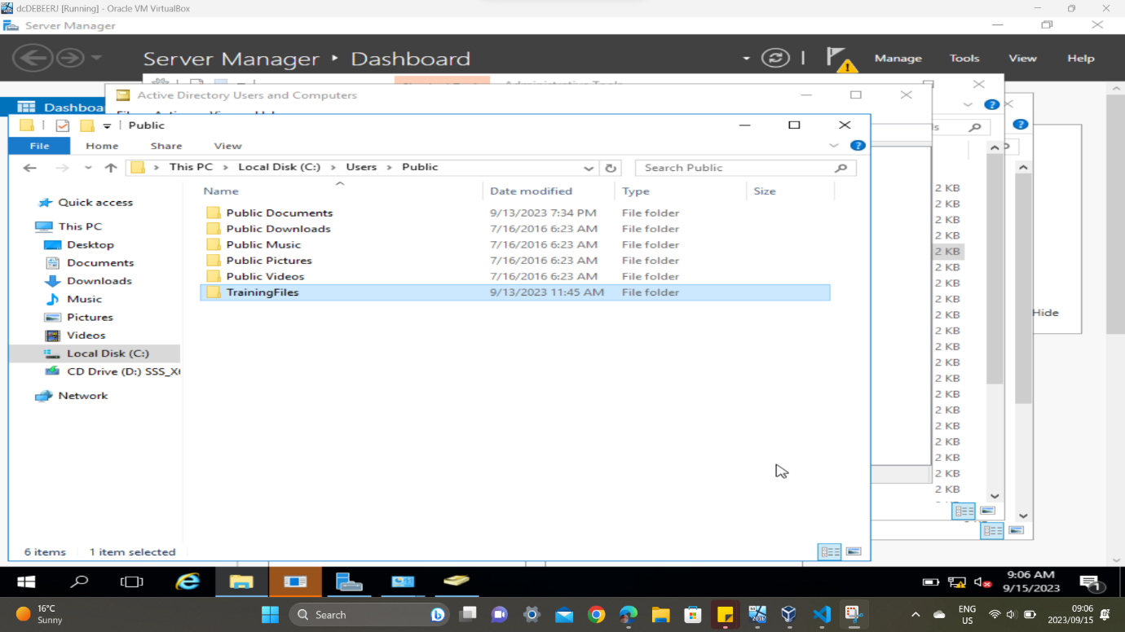

Figure 14 - Server computer: TrainingFiles

Figure 15 - Server computer: Demos and manuals

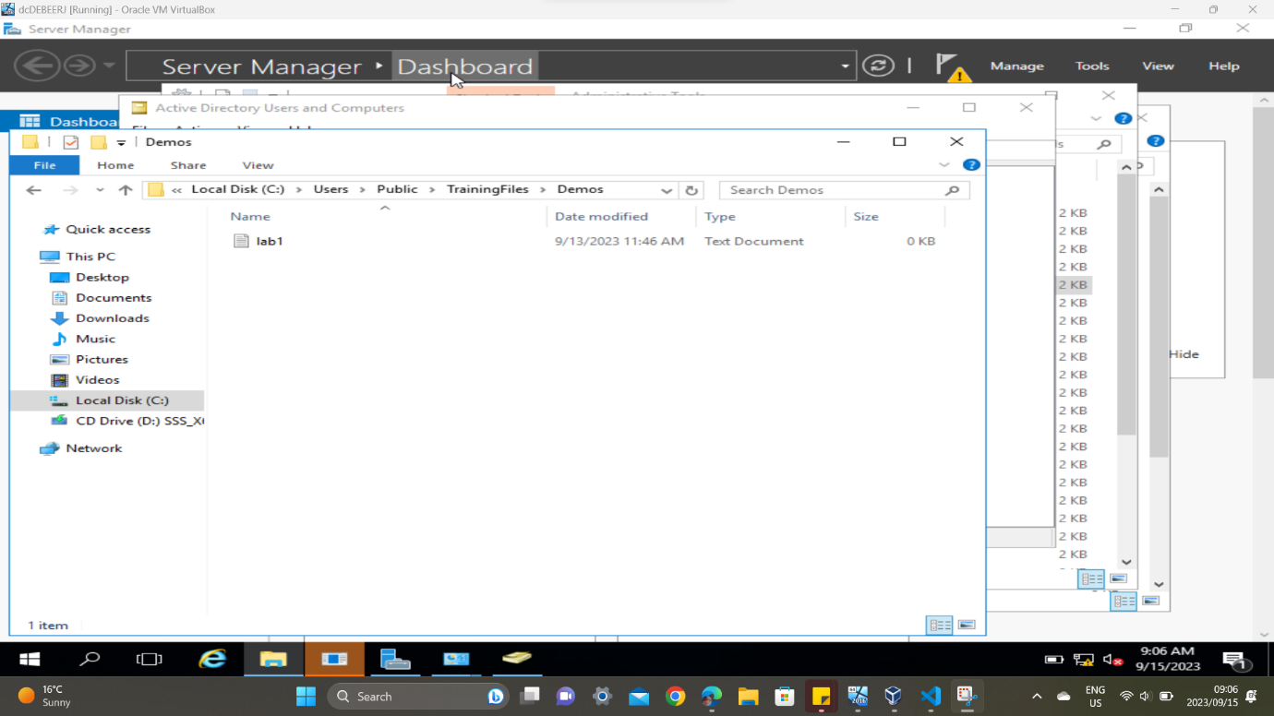

Figure 16 - Server computer: lab1

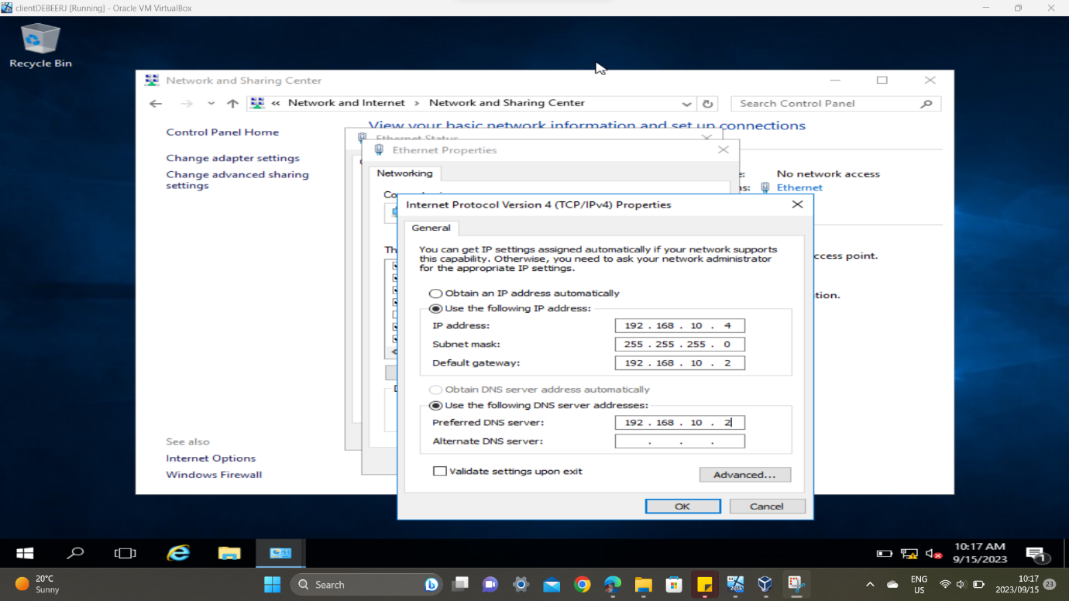

Figure 17 - Client computer: Properties

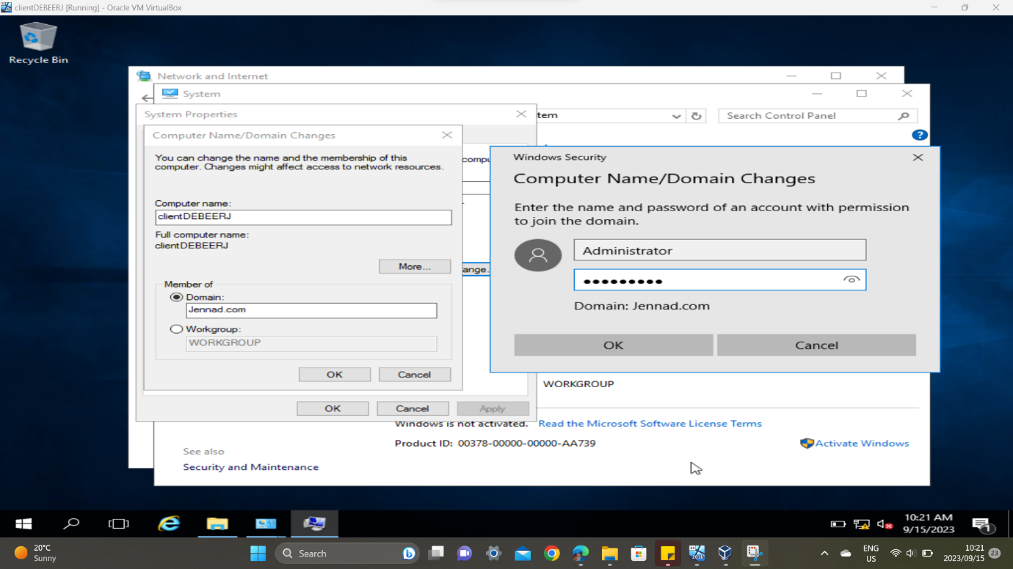

Figure 18 - Client computer: Name and domain

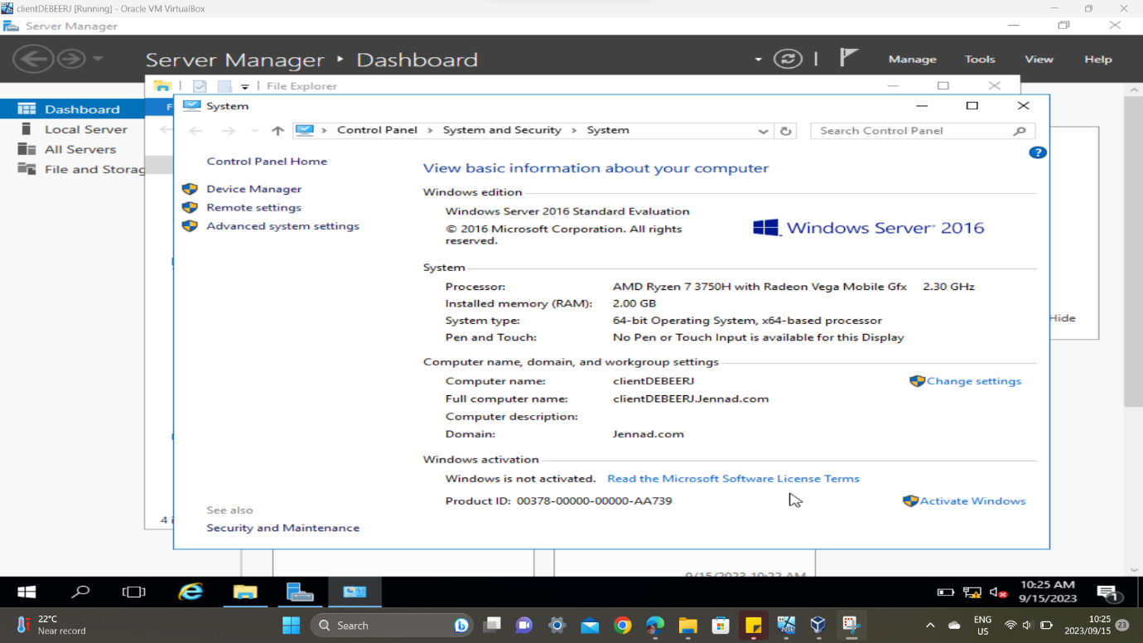

Figure 19 - Client computer: Name and domain